BADGER BOOKS

ELECTRONIC POLL BOOKS

The Village of West Milwaukee will be implementing their e-poll books during the 2023 Spring Election Primary on February 21, 2023.

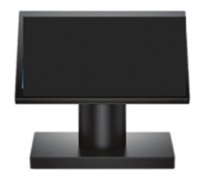

WHAT ARE THEY?

* They will replace the paper poll books
* Voters will digitally sign the screen
* Are **NOT** connected to the internet
* You still receive a paper ballot after checking in on the e-poll books

WHAT DO THEY DO?

1. Check in Voters
2. Register New Voters
3. Process Absentee Ballots

ARE THEY SAFE?

These electronic devices are **NOT** connected to the internet, and the security risk factors for the Badger Books are comparable to those using paper poll books. Badger Books do not process votes. After checking-in, you will receive your paper ballot to vote and feed into the tabulator.



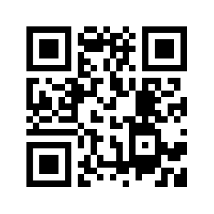CONTACT US AUTHORIZATION

Badger Books are not voting equipment, and the Wisconsin Elections Commission has authority to approve electronic poll books. Per Wis. Stat. § 6.79(1m), “the system employed to maintain the list electronically is subject to the approval of the Commission.”

Also, per Wis. Stat. § 5.05(18), "the Commission may facilitate the creation and maintenance of electronic poll lists for purposes of s. 6.79 including entering into contracts with vendors and establishing programs for development and testing.”

**Village of West Milwaukee’s Village Board approved the purchases in the 2022 budget cycle.**

**Village of West Milwaukee**

Clerk’s Office

4755 West Beloit Road

West Milwaukee, WI 53214

**Ph:** (414) 645-1530

<https://www.>westmilwaukee.org

Still unsure about Badger Books?

Watch this video: